In this project, I created a for validation using html and javascript. I have two .HTML files and two corresponding .JS files. I approached this project by taking each step one by one.

First, I created two files Validation1.html and Validation1.js. I completed the first and last name label fields, then I added the field text in the HTML file, then I added the validation rules in the JavaScript file. I then did the same thing with the gender and state label fields, created dropdown views for them and provided both correct and default options for them. I tested all the functions, then moved on.

Next, I moved onto the other two files Validation2.html and Validation2.js. By this point I fully understood how to finish the project so I completed the JavaScript file then went back and linked up the HTML file to use it. I tested all the functions then moved on.

Lastly, I went back into the Validation2.js file and added an if statement determining whether the Validation1.html had been properly completed. Then if send the user to Validation2.html to complete that verification. The user knows that all the verifications are complete based on the green checkmarks that pop up on both screens.

Validation1.html when started:

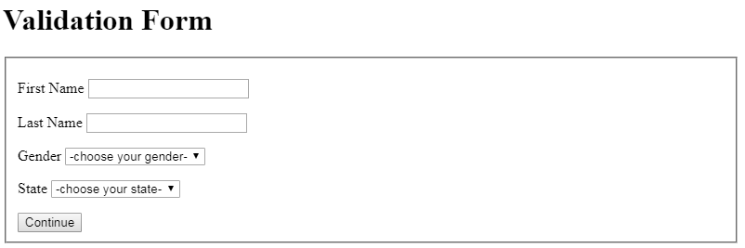

Incorrect entries:

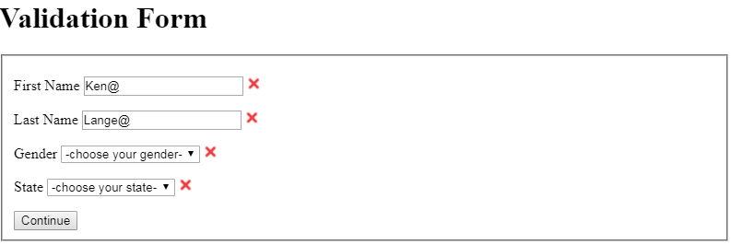

Satisfactory entries:

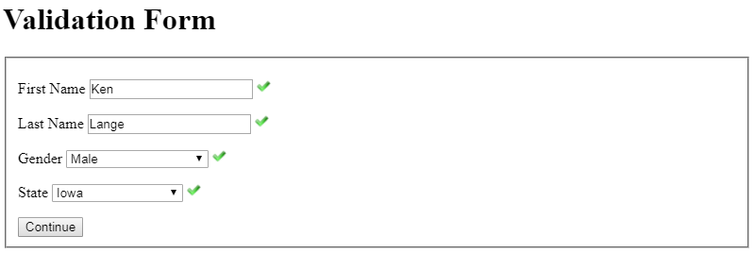

Validation2.html is started when all fields are properly satisfied:

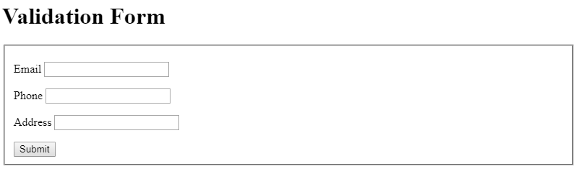

Incorrect entries:

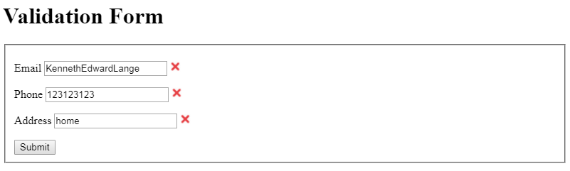

Satisfactory entries:

